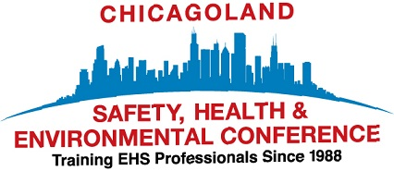
SAVE THE DATE SEPTEMBER 18-21, 2017
Naperville campus of Northern Illinois University
The CHICAGOLAND SAFETY, HEALTH & ENVIRONMENTAL CONFERENCE is again offering training sessions dealing with OSHA & EPA Compliance, Industrial Hygiene, Environmental Management, Professional Development and General Safety. Since 1988, the conference has provided professional training for business owners, managers, supervisors, safety committee members, municipalities, training professionals, human resource managers, and others with responsibilities related to health, safety and environmental management.

The Chicagoland Safety Health & Environmental Conference is the premier training event that draws attendees, speakers and vendors from across the Midwest. The 2016 conference drew over 400 people from 17 states. The Wednesday Business EXPO also provided attendees with the opportunity to view dozens of new and exciting products and business services. The Thursday Keynote Speaker was Dr. Wes Scott from the National Safety Council.

The Chicagoland Safety Health & Environmental Conference is known for offering a wide range of current issue training topics. When you visit the conference website www.chisafetyconf.org you will be able to review information about the 80 topics that were offered at the 2016 conference, which was the largest in our 29 year history. The 2017 conference will again deliver on our commitment to provide timely training presented by knowledgeable speakers including business and industry professionals, college professors, corporate trainers, attorneys, environmental consultants, OSHA Compliance Assistance Specialists and others with extensive knowledge and experience. Training sessions are 1.5 hour, half day or full day.

The Chicagoland Safety Health & Environmental Conference is organized by volunteers and co-sponsored by the Northeastern, Chicago and Three Rivers Chapters of the American Society of Safety Engineers, the Chicago Local Section of the American Industrial Hygiene Association, the Alliance of Hazardous Materials Professionals and is planned in association with OSHA, the National Safety Education Center and the Northern Illinois College of Engineering and Engineering Technology. Planning for the 2017 conference has started and frequent updates will be posted on the website www.chisafety.conf. A list of topics being offered this year will be posted on the website in June. Registration and Early bird pricing will open in mid-June.

The conference media sponsors include the Daily Herald Business Ledger and Industrial Hygiene News. Many state and local Chambers of Commerce, business, manufacturing and trade organizations also promote the conference. The conference is grateful for their continued support.

The conference week concludes with the Chicagoland EHS Golf Outing on Friday September 22, 2017 at the Village Greens of Woodridge. This annual event is a great time to have some fun, play golf, win prizes and enjoy networking with conference attendees.

For more information, please contact Ken Orms at k.orms@att.net

